
CSA15 – CLOUD COMPUTING AND BIG DATA ANALYTICS

ASSIGNMENT 1 – CO1
Design, Analyse and Validate a Cloud-Based Solution for Migrating a Legacy University Management System
CO1: Apply cloud computing technologies including hardware–software evolution, virtualization, web services, and service models to develop cloud-based solutions.

Field | Details | Field | Details
Student Name | Vaka Anish Reddy | Register Number | 192572055
Department / Section | CSE(AI) | Academic Year / Semester | 2026
Faculty Name | R.Latha | Nature of Assignment | Individual
Duration | 1 Week | Total Marks | 50
Submission Date | 31-10-26 | Evaluation Date | 31-10-26

MARK SHEET (Rubric-based evaluation)
Task | Title | Max | Awarded | Evidence / evaluation focus
1 | Introduce Cloud Computing | 3 |  | Definition; characteristics; deployment models; scenario mapping
2 | Trace Evolution and Hardware Evolution | 3 |  | Timeline; hardware evolution; relevance to university
3 | Analyse Internet Software Evolution | 3 |  | Web/software evolution; SOA; APIs; scenario relevance
4 | Apply Server Virtualization | 5 |  | Hypervisor types; VM/container comparison; consolidation; limitations
5 | Apply Web Services | 4 |  | SOA and SOAP/REST; three university APIs; request/response examples
6 | Analyse IaaS, PaaS and SaaS | 5 |  | Responsibility layers; five-application mapping; comparison; providers
7 | Examine XaaS | 3 |  | Four or more variants; two justified choices; provider risks
8 | Design Cloud Solution Architecture | 5 |  | Labelled diagram; deployment/service models; scaling; security; DR
9 | Hands-on Implementation and Documentation | 4 |  | Running VM/container; PaaS/SaaS; tests; actual screenshots
10 | Evaluate and Recommend Final Solution | 7 |  | Three-way comparison; 3-year costs; risks; phased roadmap
11 | Day-4 Design Challenge | 8 |  | Impact; evaluation; adaptation; evidence-based defence
 | TOTAL | 50 |  | Percentage :

EVIDENCE VERIFICATION CHECKLIST

Tasks | Evidence expected | Status (✓ / P / ✗) | Evaluator note
1–3 | Conceptual explanations, comparisons and relevant illustrations | ✓ | Explanations and relevant scenario mapping documented
4 | Virtualization calculations with stated assumptions and peak-load caution | ✓ | Calculations present; practical capacity validation recommended
5–7 | API examples, service responsibility table and justified XaaS choices | ✓ | Required conceptual evidence documented
8 | Labelled architecture diagram, caption below figure and component justification | ✓ | Architecture documented; sizing assumptions need testing
9 | Actual code, environment details, execution logs, API outputs and screenshots | P | Procedures provided; actual execution evidence not established
10 | Cost assumptions, 3-year totals, risk controls and migration roadmap | ✓ | Estimates and rationale documented
11 | Day-4 changes, 10× load strategy, 99.9% target and 40-college isolation | ✓ | Design analysis documented; practical validation pending

IMPLEMENTATION EVIDENCE CHAIN

Evidence item | Status | Observation
Source code | ✓ | Flask REST API and Dockerfile provided in the proposed implementation
Virtualization | P | Docker container configuration documented; running-container evidence required
PaaS or SaaS | P | Managed web-service deployment procedure described; live deployment not verified
Functional test | P | Expected HTTP 200 response and JSON output documented; actual output required
Failure case | P | HTTP 404 test case documented; actual execution record required
Screenshots | P | Screenshot requirements identified; authentic screenshots need verification
Reproducibility | ✓ | Build commands, run commands, endpoints and expected results specified

OVERALL REMARKS

_______________  Student Signature | _______________  Faculty Signature | _______________  Program Director
MANDATORY SUBMISSION EVIDENCE CHECK
✓ = Present in documented answer; P = Partly present; ✗ = Missing / not satisfied
Task | Evidence expected | Status | Evaluator note
1 | Cloud definition, characteristics, deployment models and scenario mapping | ✓ | All conceptual requirements covered
2 | Evolution timeline, hardware development and university relevance | ✓ | Well explained with relevant examples
3 | Internet software evolution, SOA and APIs | ✓ | Clear explanation and scenario relevance
4 | Hypervisors, VM/container comparison and consolidation calculations | ✓ | Calculations included; peak-load limitations discussed
5 | SOAP/REST comparison and three university APIs | ✓ | API methods and request/response examples documented
6 | IaaS/PaaS/SaaS responsibility layers and application mapping | ✓ | All five applications categorized with justification
7 | XaaS variants and two justified selections | ✓ | Six variants explained; DBaaS and DRaaS recommended
8 | Labelled architecture, scaling, security and disaster recovery | ✓ | Design and component justifications documented
9 | Working container, PaaS/SaaS deployment, actual tests and screenshots | P | Code and procedures provided; actual execution evidence requires verification
10 | Three-year cost comparison, risks and migration roadmap | ✓ | Cost assumptions, calculations and recommendations included
11 | Impact analysis, 10× load, 99.9% availability and tenant isolation | ✓ | Changed requirements evaluated; load-test evidence recommended

IMPLEMENTATION EVIDENCE CHAIN
Evidence item | Status | Observation
Source code | ✓ | Python Flask REST API and Dockerfile documented
Virtualization | P | Docker build and run procedures provided; execution screenshot required
PaaS or SaaS | P | Cloud deployment steps described; actual deployment confirmation required
Functional test | P | HTTP 200 and expected JSON response documented; actual test output required
Failure case | P | HTTP 404 test case included; execution evidence required
Screenshots | P | Required screenshots identified but authenticity and completeness not verified
Reproducibility | ✓ | Installation, configuration, commands and testing steps documented
Interpretation | ✓ | Technical outcomes and implementation limitations explained
Code and report consistency | ✓ | Proposed API, Docker configuration and testing procedure are aligned

SUBMISSION CHECKLIST (Not Separately Marked)
Requirement | Status
All 11 tasks answered | ☒ Yes ☐ Partly ☐ No
Cloud concepts and comparisons explained | ☒ Yes ☐ Partly ☐ No
Virtualization calculations included | ☒ Yes ☐ Partly ☐ No
API examples and service models explained | ☒ Yes ☐ Partly ☐ No
Cloud architecture diagram included | ☒ Yes ☐ Partly ☐ No
Implementation and testing evidence provided | ☐ Yes ☒ Partly ☐ No
Three-year cost analysis and roadmap included | ☒ Yes ☐ Partly ☐ No
Day-4 design challenge completed | ☒ Yes ☐ Partly ☐ No
Figures and screenshots included | ☐ Yes ☒ Partly ☐ No
Table and figure numbering correct | ☐ Yes ☒ Partly ☐ No
Viva recommended | ☒ Yes ☐ No

CSA15 – Cloud Computing and Big Data Analytics
ASSIGNMENT 1
CO1: Apply cloud computing technologies including hardware–software evolution, virtualization, web services, and service models to develop cloud-based solutions.

Assignment Title: Design, Analyse and Validate a Cloud-Based Solution for Migrating a Legacy University Management System (Total Marks – 50)
Duration: 1 week
Scenario – Smart Campus Cloud Migration
A multi-campus university currently runs its Student Information System, Learning Management System, Library System, Exam Portal and Email on ageing physical servers in a single on-premise data centre. Each application has its own dedicated server, which stays idle for most of the year but fails to cope during admissions, result publication and online-exam weeks.
The university's current environment is:
- 12 physical servers, average CPU utilisation of about 15%, with peaks above 95% during admissions and exams
- Approximately 25,000 students and 2,000 staff across 4 campuses
- Applications built as large monolithic programs, with no public interfaces for mobile apps or partner colleges
- High capital expenditure, slow procurement (6–8 weeks per server) and no disaster recovery site
As a cloud consultant, you must study how computing evolved to the cloud model, and then design a cloud-based solution that uses virtualization, web services and an appropriate mix of service models (IaaS, PaaS, SaaS and XaaS) for the university. All recommendations must be justified in terms of cost, scalability, availability and manageability.
Design Challenge:
On Day 4, the university announces that it will launch a mobile app and open student-record and fee-payment services to 40 affiliated colleges. Expected load is 10 times the current peak, with a requirement of 99.9% availability and a limited operating budget. Re-evaluate your original design and decide whether it should be retained, modified or redesigned.
TASK 1 – Introduce Cloud Computing and Map It to the Scenario (3 Marks)
Design and Propose cloud computing model for the context of the university's problems.
- Definition of cloud computing and the five essential characteristics (on-demand self-service, broad network access, resource pooling, rapid elasticity, measured service)
- Deployment models (public, private, hybrid, community) and which one suits the university
- Three problems of the current on-premise setup and how each cloud characteristic addresses them
- Benefits and limitations of cloud adoption for the university
Evidence Expected
A clear explanation of cloud characteristics and deployment models, mapped to the university's actual problems.
TASK 2 – Trace the Evolution and Hardware Evolution (3 Marks)
Trace how computing infrastructure evolved to make cloud computing possible.
- A timeline from mainframes, minicomputers and PCs, to client–server, clusters, grid computing, utility computing and cloud
- Hardware evolution: multi-core processors, commodity servers, high-capacity storage, high-speed networking and data centres
- How each stage solved a limitation of the previous one
- Which stage the university's current system corresponds to, with reasons
Evidence Expected
A labelled timeline or diagram, with a justified explanation of how hardware advances enabled the cloud.
TASK 3 – Analyse Internet Software Evolution (3 Marks)
Explain how internet software evolved and why it supports cloud services.
- Evolution from static web pages to dynamic web, Web 2.0, SOA, mashups and cloud-hosted applications
- Role of browsers, HTTP, AJAX and APIs in delivering software over the internet
- Comparison between desktop software, client–server software and web-delivered software
- How this evolution affects the design of the university's applications
Evidence Expected
A comparative explanation of software evolution stages, linked to the university's application design.
TASK 4 – Apply Server Virtualization (5 Marks)
Apply server virtualization to consolidate the university's 12 physical servers.
- Explain how a hypervisor works, and distinguish Type-1 and Type-2 hypervisors, with examples
- Compare full virtualization, para-virtualization, OS-level virtualization (containers) and hardware-assisted virtualization
- Propose which applications should run as virtual machines and which as containers, with reasons
- Calculate the consolidation: with an average utilisation of 15% per server and a target host utilisation of 70%, estimate how many physical hosts are needed (show your assumptions and working)
- Discuss live migration, snapshots and resource over-commitment as benefits, and the risks of virtualization (noisy neighbour, hypervisor failure, security isolation)
Show your calculation. A final number without working will not receive full credit.
Evidence Expected
A justified virtualization plan with a worked consolidation calculation and discussion of benefits and risks.
TASK 5 – Apply Web Services (4 Marks)
Analyse web services to expose the university's functions to other systems.
- Overview of web services and their role in cloud and SOA
- Compare SOAP, WSDL, UDDI and RESTful services (HTTP methods, JSON/XML)
- Identify at least three university functions to expose as web services (for example, result lookup, fee payment, library search) and define the endpoint, method and sample request/response for each
- Justify whether SOAP or REST is more suitable for each function
Evidence Expected
A defined set of web services with sample request/response formats and a justified choice of SOAP or REST
TASK 6 – Analyse the Service Models: IaaS, PaaS and SaaS (5 Marks)
Analyse which service model fits each university application.
- Define IaaS, PaaS and SaaS, and show who manages which layer (hardware to application) in each model
- Categorise the five university applications (SIS, LMS, Library, Exam Portal, Email) into IaaS, PaaS or SaaS, with reasons
- Compare the models on control, cost, scalability, maintenance effort and vendor lock-in
- Give one real provider example for each model
Present your categorisation in a table, but explain the reasoning behind each decision. A table alone is not sufficient.
Evidence Expected
A reasoned mapping of applications to service models, supported by a layer-wise responsibility comparison.
TASK 7 – Examine XaaS (3 Marks)
Examine the broader XaaS (Anything-as-a-Service) concept for the university.
- Explain XaaS and describe at least four variants (for example DaaS, BaaS/MBaaS, FaaS, DBaaS, Security-as-a-Service, Disaster-Recovery-as-a-Service)
- Select two XaaS offerings that would benefit the university, and justify them
- Discuss the risks of over-reliance on multiple 'as-a-Service' providers
Evidence Expected
An analysis of XaaS variants, with justified selection of two offerings for the university.
TASK 8 – Design the Cloud Solution Architecture (5 Marks)
Bloom's Level: Level 6 – Create | Action verbs: Design, Construct, Propose
Create a complete cloud architecture for the university by combining virtualization, web services and service models.
- An architecture diagram showing users, load balancer, web/application tier, database tier, storage, API layer and DR region
- The deployment model and the service model chosen for each component
- How elasticity (auto-scaling) will handle admissions and exam peaks
- Basic security and availability measures (access control, encryption, backup, multi-zone deployment)
Evidence Expected
A labelled architecture diagram with written justification for each component and design decision.
TASK 9 – Hands-on Implementation and Documentation (4 Marks)
Implement a small proof-of-concept of your design using a free-tier cloud account or a local virtualization tool.
- Create a virtual machine or container (using AWS/Azure/GCP free tier, VirtualBox, or Docker) and host a simple web page or REST API for one university function
- Deploy a SaaS or PaaS component (for example a cloud-hosted database, a serverless function or a static site)
- Test the web service with a client (browser, Postman or curl) and record the output
- Provide screenshots, configuration steps and any issues faced
Evidence Expected
Annotated screenshots and clear, reproducible steps showing that the proof-of-concept works.
TASK 10 – Evaluate and Recommend the Final Solution (7 Marks)
Evaluate your design and recommend the final cloud solution for the university.
- Compare on-premise, IaaS-based and PaaS/SaaS-based options on cost (CapEx vs OpEx), scalability, availability, security and effort
- Estimate a simple 3-year cost comparison using stated assumptions
- Identify the main risks (vendor lock-in, data privacy, downtime, skills gap) and give mitigation steps
- Provide your final recommendation and a short migration roadmap (which application moves first, and why)
Your recommendation must be supported by the analysis in the previous tasks. Choosing a popular cloud provider without justification is not sufficient.
Evidence Expected
A technically justified recommendation, supported by a cost comparison, risk analysis and migration roadmap.
DAY-4 DESIGN CHALLENGE
TASK 11 – Re-evaluate and Adapt the Design (8 Marks)
Changed Requirement
The university will now launch a mobile app and open student-record and fee-payment services to 40 affiliated colleges. Expected load is 10 times the current peak, availability must be 99.9%, and the operating budget is limited.
Re-evaluate your original design in response to these changed conditions. You may:
RETAIN → MODIFY → or REDESIGN
your original solution.
Impact Analysis – 2 Marks
Discuss:
- What has changed from the original problem
- Which original assumptions (load, users, availability, cost) are affected
- Why the web services and APIs now become critical
- How multi-tenant access by 40 colleges affects security and isolation
Evidence Expected: A clear analysis of how the changed requirements affect the original cloud design.
Evaluation of the Original Design – 2 Marks
Discuss:
- Whether the chosen service models and virtualization plan can handle a 10x load
- Whether auto-scaling and the single-region deployment are sufficient for 99.9% availability (about 8.76 hours of downtime allowed per year)
- Whether cost remains acceptable under the new load
- Whether another service model or XaaS offering would give better overall results
Evidence Expected: A technically supported evaluation of the original design under the new conditions.
Adaptation or Redesign – 2 Marks
Discuss:
- Decide whether to retain, modify or redesign the solution
- Describe the revised architecture (for example API gateway, container orchestration, serverless components, multi-zone deployment or a hybrid model)
- Explain what changed in the service model mix and in the virtualization approach
- If you retain the original design, give sufficient technical justification for why no change is required
Evidence Expected: An appropriate design response to the changed requirement, with clear technical reasoning.
Evidence-Based Defence – 2 Marks
Discuss:
- Capacity and availability calculations
- Cost comparison between the original and the revised design
- Security and multi-tenancy considerations
- Trade-offs such as vendor lock-in, complexity and migration effort
Evidence Expected: A well-supported final decision that follows logically from the analysis.
MARK DISTRIBUTION
Task | Title | Bloom's Level | Marks
Task 1 | Cloud Computing – Introduction & Characteristics | L2 – Understand | 3
Task 2 | Evolution & Hardware Evolution | L2 – Understand | 3
Task 3 | Internet Software Evolution | L2 – Understand | 3
Task 4 | Server Virtualization | L3 – Apply | 5
Task 5 | Web Services | L3 – Apply | 4
Task 6 | Service Models: IaaS, PaaS, SaaS | L4 – Analyze | 5
Task 7 | XaaS | L4 – Analyze | 3
Task 8 | Design the Cloud Solution Architecture | L6 – Create | 5
Task 9 | Hands-on Implementation & Documentation | L3 – Apply | 4
Task 10 | Evaluate & Recommend the Final Solution | L5 – Evaluate | 7
 | Subtotal

Task 11 | Day-4 Design Challenge | L4 / L5 / L6 | 8
 | TOTAL |  | 50

1 – INTRODUCTION TO CLOUD COMPUTING

1. Introduction and core concepts
Meaning and definition. Cloud computing is a model for delivering computing resources—such as servers, storage, databases, networking and software—over the internet whenever they are required. Instead of purchasing and maintaining all hardware inside the university, the institution rents resources from a cloud provider and pays according to usage. The provider operates the physical data centre, while the university configures and manages the services it uses.
Five essential characteristics. 1. On-demand self-service: authorised staff can create resources without waiting for manual provider action. 2. Broad network access: students and staff can use services through laptops, phones and browsers. 3. Resource pooling: provider resources are shared securely among customers. 4. Rapid elasticity: capacity can increase during admissions and online examinations and decrease afterwards. 5. Measured service: usage such as storage, processing and network traffic is monitored for billing and planning.
Problems in the present university. The university has 12 physical servers with average CPU utilisation of about 15%, but demand rises above 95% during admissions and examinations. Dedicated servers remain idle in normal periods, while peak periods cause slow service. Procurement takes 6–8 weeks, and there is no disaster-recovery site. Cloud elasticity addresses peak demand; resource pooling improves utilisation; and on-demand provisioning avoids long hardware procurement delays.
Recommended deployment model. A hybrid cloud is suitable. Public-cloud services can host the student portal, learning platform, APIs and scalable web applications. Sensitive records can be protected using private networking, encryption and tightly controlled database access. The university can retain selected legacy systems on-premises during migration. A community cloud may be considered for shared services among affiliated colleges, but it is not necessary as the primary model.
Cloud computing changes the university's capacity-planning approach. Instead of buying enough hardware for the busiest week and leaving it under-used for the rest of the year, the university can scale services according to measured demand. This is particularly useful for admissions, fee deadlines and online examinations.
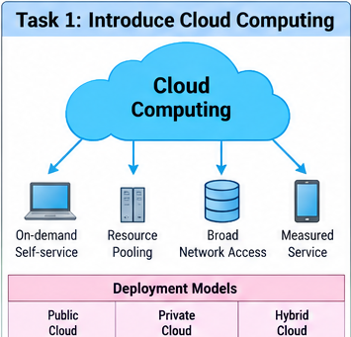
1.1Cloud service flow for the Smart Campus

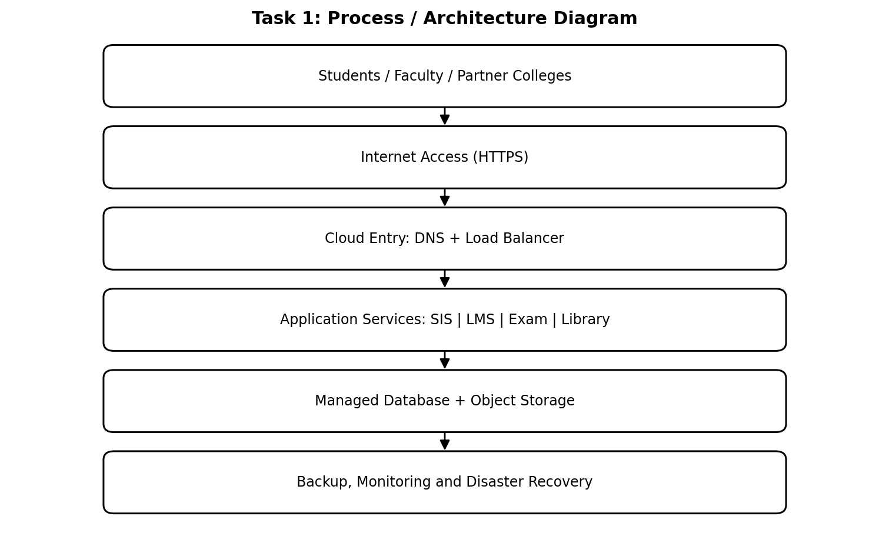

1.2. Explanation of the diagram
How the request is handled. A student opens the portal using a browser or mobile application. The request travels over HTTPS to the cloud load balancer, which directs it to a healthy application instance. The application checks identity and permissions, reads or updates the relevant database, and returns the result. Backups are copied to a separate recovery location.
Benefits and limitations. Benefits include lower initial capital expenditure, quick provisioning, flexible capacity, remote access, managed maintenance and improved recovery options. Limitations include dependence on internet connectivity, recurring usage charges, vendor lock-in, data-residency obligations and the need for trained administrators. Cloud adoption does not automatically make an application secure; the university must configure identity, network and data controls.
Process interpretation: Each stage has a defined responsibility. Requests enter through a controlled network interface, are checked and processed by the relevant service, and reach stored information only through authorised application logic. The response then returns to the original user or calling application.

1.3 Deployment model comparison and scenario mapping

Model | Description | University use | Main consideration
Public cloud | Provider-owned shared infrastructure, logically isolated | Student portal, public APIs, scalable web tier | Strong access controls and data protection are required
Private cloud | Cloud environment dedicated to one organisation | Highly controlled legacy or sensitive workloads | Higher cost and management effort
Hybrid cloud | Combination of private/on-premises and public cloud | Recommended migration approach | Integration and consistent security are essential
Community cloud | Shared by organisations with common requirements | Possible shared platform for affiliated colleges | Governance and responsibility must be agreed

1.4. Analysis and application to the university
Characteristic-to-problem mapping. Rapid elasticity reduces overload during admission and exam peaks. Resource pooling reduces the waste caused by 12 lightly used servers. On-demand self-service reduces the 6–8 week wait for new hardware. Broad network access supports four campuses and remote users. Measured service helps the university monitor and control spending.
Final proposal. Adopt a hybrid-cloud strategy and migrate in phases. Begin with a low-risk web service, then move the LMS and student-facing portal, followed by carefully tested database workloads. Apply encryption, multi-factor authentication, role-based access, backups and monitoring from the first phase. This approach balances scalability, cost, security and manageability.
Therefore, a hybrid deployment model is the most balanced choice because it supports gradual migration, elastic public-facing services and controlled handling of sensitive university data.

TASK 2 – EVOLUTION OF COMPUTING AND HARDWARE

2. Introduction and core concepts
Evolution of computing infrastructure. Cloud computing became practical through several stages. Mainframes centralised processing for many users. Minicomputers made computing more accessible to departments. Personal computers brought processing to individual users. Client–server systems separated user interfaces from shared servers. Clusters connected multiple computers to work as one system. Grid computing coordinated distributed resources, while utility computing introduced usage-based delivery. Cloud computing combines network access, pooling, automation and elasticity.
Hardware developments that enabled cloud. Multi-core processors allow one server to run many workloads concurrently. Commodity servers provide scalable capacity at lower cost than specialised machines. High-capacity storage supports large databases, files and backups. High-speed networks connect servers and users with low latency. Large data centres provide power, cooling, physical security and redundant connectivity. Hardware virtualisation support makes it possible to divide a physical machine into isolated virtual machines.
University's current stage. The university's 12 dedicated physical servers represent a traditional client–server / on-premises data-centre model. Each application has its own server, leading to average CPU utilisation of only about 15%. The system is centralised but not elastic. The rise above 95% during peak periods shows that fixed capacity is poorly matched to variable demand.
The evolution is not simply a sequence of faster computers. Each stage changed how computing resources were shared, managed and accessed. Cloud computing combines distributed infrastructure with automation, metering, standard interfaces and service-level management.
The university's existing dedicated servers show why hardware ownership alone does not guarantee good utilisation. Consolidation and cloud provisioning use modern hardware more efficiently, but the capacity plan must still account for peak demand and failure reserve.
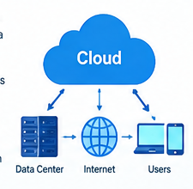
2.1 Computing evolution timeline

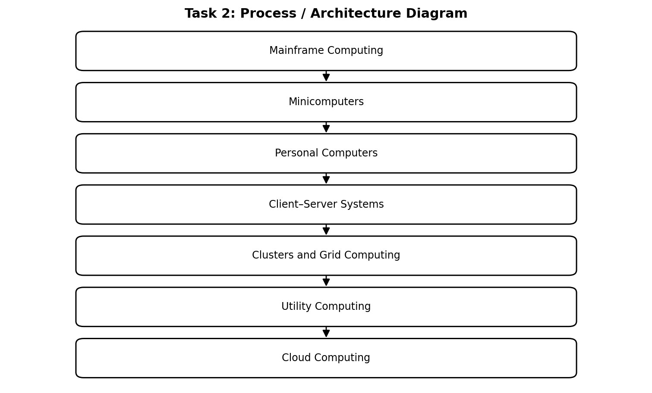

2.2. Explanation of the diagram
How each stage solved a limitation. Mainframes offered central control but were expensive and concentrated. Minicomputers reduced the cost of departmental access. PCs improved individual access but created isolated data. Client–server systems enabled shared databases and applications. Clusters improved performance and availability. Grid computing used geographically distributed resources. Utility computing introduced metering. Cloud computing added self-service provisioning, broad access and rapid elasticity.
Hardware-to-cloud relationship. For example, multi-core processors and a hypervisor allow one physical host to run separate SIS, library and application virtual machines. High-speed networks connect these services across four campuses. Replicated storage supports backups and disaster recovery. These advances make a shared cloud platform practical.
Process interpretation: Each stage has a defined responsibility. Requests enter through a controlled network interface, are checked and processed by the relevant service, and reach stored information only through authorised application logic. The response then returns to the original user or calling application.

2.3. Comparison of infrastructure stages

Stage | Main feature | Limitation addressed | Example in university context
Mainframe | Central computer for many terminals | Shared access instead of separate machines | Central student records processing
PC | Personal computing | Individual access and local productivity | Staff desktop applications
Client–server | Clients use central servers | Shared data and services | Current SIS and library servers
Cluster / Grid | Multiple connected computers | Performance and distributed capacity | Parallel analytics or batch processing
Utility computing | Metered computing resources | Pay according to consumption | Usage-based infrastructure
Cloud | On-demand pooled elastic services | Fixed-capacity and slow provisioning | Elastic student portal and exam platform

2.4. Analysis and application to the university
Key comparison. Traditional infrastructure requires the university to buy capacity before it is needed. Cloud infrastructure allows capacity to be provisioned as demand changes. Clusters and grids contribute distributed processing, while cloud adds service management, APIs, automated provisioning and measured usage.
Conclusion. The university should move from dedicated physical servers towards virtualised and cloud-hosted services. The move is possible because modern processors, storage, networking and data-centre engineering provide the foundation for safe resource sharing. Migration should be gradual so that legacy applications can be tested before retirement.
Therefore, the university's infrastructure should progress from isolated dedicated servers to a virtualised and cloud-enabled platform, with capacity validated against real workload measurements.

3 – EVOLUTION OF INTERNET SOFTWARE

3. Introduction and core concepts
From static web to cloud applications. Early websites delivered static HTML pages. Dynamic websites later generated pages using server-side programs and databases. Web 2.0 introduced interactive, user-generated and collaborative experiences. Service-Oriented Architecture (SOA) organised software as reusable services with defined interfaces. Mashups combined data or functions from multiple services. Cloud-hosted applications now deliver complete software capabilities through browsers, mobile applications and APIs.
Role of internet technologies. A browser displays the user interface and sends requests. HTTP/HTTPS defines request and response communication. AJAX allows a page to retrieve data asynchronously without reloading the entire page. APIs expose functions in a controlled and documented way. JSON is a compact data format commonly used by REST APIs; XML is structured and is often used with SOAP-based services. HTTPS protects data in transit through encryption.
Relevance to the university. The current university applications are monolithic and have no public interfaces for mobile apps or partner colleges. A service-based design can expose student profile, result, fee and library functions through APIs. The mobile app and 40 affiliated colleges can then use the same controlled interfaces instead of directly accessing internal databases.
The important change is the separation of the presentation layer from business logic and data. A student mobile app, college portal and browser interface can all call the same documented service. This reduces duplicated code and allows the university to control access centrally.
A web application should not expose internal database credentials or accept arbitrary database queries from clients. It should expose narrowly defined business operations, validate every input and return only the information required by the caller.

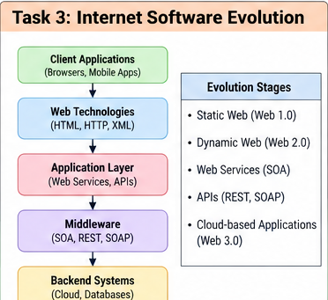
3.1. Internet software request flow

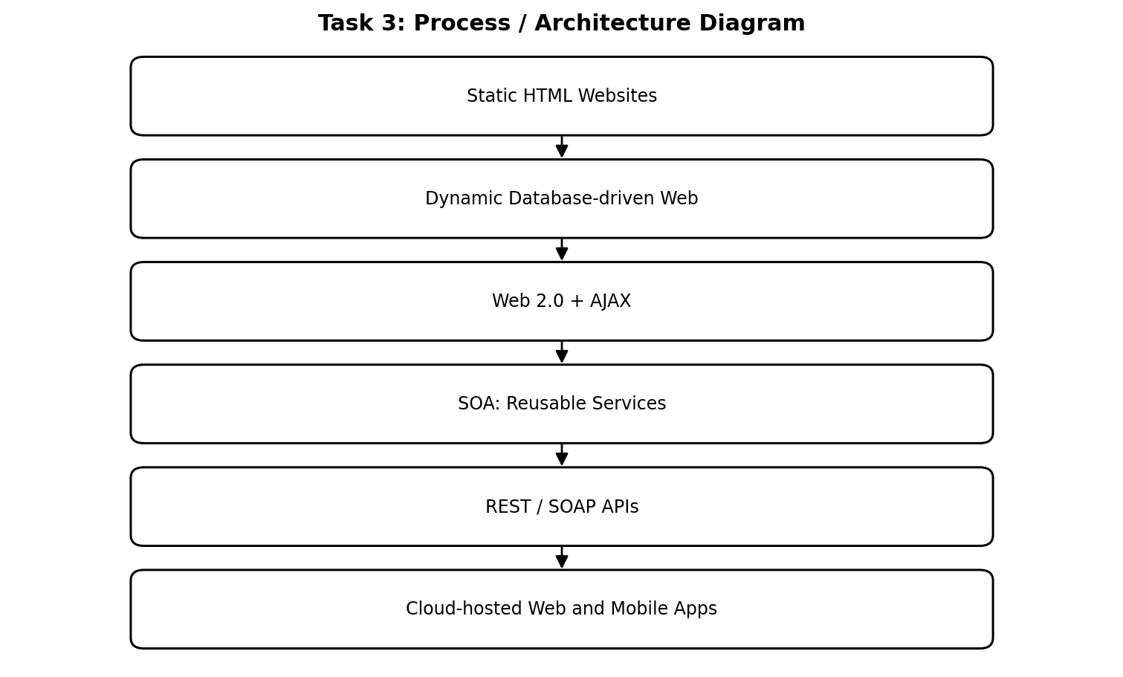

3.2. Explanation of the diagram
Example interaction. A student selects “View Result” in the mobile app. The app sends an HTTPS GET request to the result API with the student's authorised identity. The API verifies access, retrieves the result from the database and returns a JSON response. The app displays the subject and marks without receiving direct database credentials.
Why APIs matter. APIs separate the user interface from internal implementation. The university can update the database or application without rewriting every client, provided the API contract remains compatible. Rate limits, authentication, validation and logging help protect services when many colleges connect.
Process interpretation: Each stage has a defined responsibility. Requests enter through a controlled network interface, are checked and processed by the relevant service, and reach stored information only through authorised application logic. The response then returns to the original user or calling application.

3.3. Software delivery comparison
Aspect | Desktop software | Client–server software | Web-delivered software
Installation | Installed on each computer | Client software plus server | Usually accessed through browser/app
Updates | Often manual per device | Client and server updates | Central server-side updates
Access | Usually device-bound | Network-connected clients | Internet-connected authorised users
Integration | May be limited | Depends on interfaces | APIs support integration
University example | Local office package | Legacy SIS client | Cloud student portal / LMS

3.4. Analysis and application to the university
SOA and APIs. SOA encourages reusable services such as identity, student records, payments and library search. Each service has a clear contract. REST is useful for lightweight web and mobile interactions. SOAP may be appropriate where formal contracts and enterprise messaging requirements exist.
Design recommendation. Break the monolithic system into manageable services over time. Begin with read-only result lookup and library search, then add fee payment with stronger transaction controls. Put an API gateway in front of services, use HTTPS, validate every request, apply role-based access and record audit logs. This evolution improves integration while reducing the risk of replacing the entire system at once.
Therefore, API-based web software is the suitable direction for the university because it supports the mobile application, browser portal and partner-college integration through common controlled interfaces.

4 – SERVER VIRTUALIZATION

4. Introduction and core concepts
Meaning and working of virtualization. Server virtualization uses a software layer called a hypervisor to divide one physical server into multiple virtual machines (VMs). Each VM receives virtual CPU, memory, storage and network interfaces and can run its own operating system. The hypervisor schedules access to the physical hardware and isolates the VMs. This allows the university to consolidate lightly used servers while keeping workloads logically separate.
Hypervisor types. A Type-1 (bare-metal) hypervisor runs directly on physical hardware. Examples include VMware ESXi, Microsoft Hyper-V and Xen. It is generally suitable for production data centres. A Type-2 hypervisor runs as an application on a host operating system, such as Oracle VirtualBox or VMware Workstation, and is useful for labs, testing and demonstrations.
Worked consolidation calculation. Given: 12 physical servers; average CPU utilisation per server = 15%; target host utilisation = 70%. Assume all 12 servers have equal CPU capacity and average demand is representative. Total equivalent CPU demand = 12 × 15% = 180% of one server's capacity. Required hosts = 180% ÷ 70% = 2.57. Round up to 3 hosts. This is a theoretical average-load estimate; memory, storage, network, failover reserve and peak demand may require additional capacity. A practical design should test peak workloads and N+1 resilience.
The 3-host result is based only on average CPU demand. It does not prove that three hosts will safely handle every peak. The university must also compare RAM, storage capacity, disk I/O, network throughput and application licensing before purchasing equipment.
For high availability, the design should consider what happens if one host fails. If all three hosts are heavily loaded, losing one may overload the remaining two. A practical design therefore keeps spare capacity and validates failover under realistic peak-load tests.
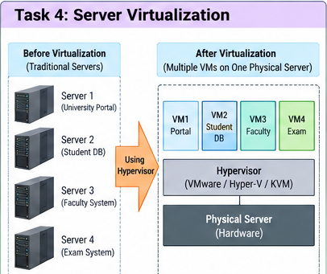
4.1. Virtualized server architecture

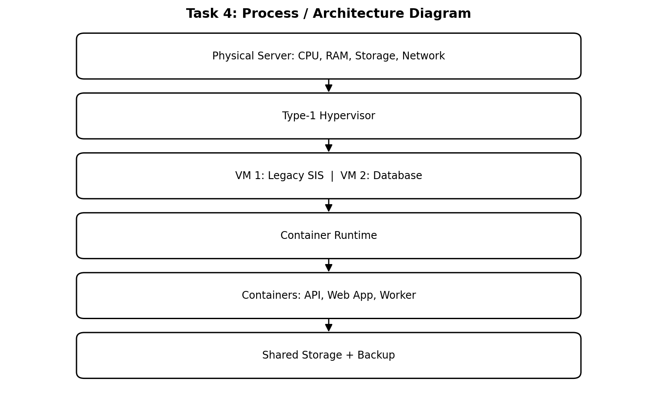

4.2. Explanation of the diagram
VMs and containers in the university. Use VMs for legacy applications that require a separate operating system, database servers needing controlled configuration, and workloads that cannot yet be refactored. Use containers for stateless web services, API services and background workers because they package application dependencies and start quickly. Persistent databases need durable storage and careful backup regardless of packaging.
Virtualization approaches. Full virtualization presents virtual hardware to an unmodified guest OS. Para-virtualization uses guest awareness or specialised interfaces to improve interaction with the hypervisor. OS-level virtualization uses containers that share the host kernel. Hardware-assisted virtualization uses processor features such as Intel VT-x or AMD-V to improve VM execution and isolation.
Process interpretation: Each stage has a defined responsibility. Requests enter through a controlled network interface, are checked and processed by the relevant service, and reach stored information only through authorised application logic. The response then returns to the original user or calling application.

4.3. Virtualization comparison, benefits and risks

Technology | Isolation / OS | Typical use | Example
Full virtualization | Separate guest OS; virtual hardware | Legacy SIS and database VM | VMware ESXi VM
Para-virtualization | Guest-aware interfaces or drivers | Optimised virtual I/O | Xen PV mode
OS-level virtualization | Shares host kernel | API and web microservices | Docker container
Hardware-assisted virtualization | Uses CPU virtualisation extensions | Production VMs | KVM / ESXi with VT-x or AMD-V

4.4. Analysis and application to the university
Benefits and risks. Live migration moves a running VM between hosts with limited interruption when supported by shared storage and compatible hosts. Snapshots capture a point-in-time VM state for short-term rollback, but they are not a replacement for independent backups. Resource over-commitment can improve average utilisation, but excessive over-commitment causes contention. Risks include noisy-neighbour effects, hypervisor failure, misconfiguration and weak isolation.
Implementation plan. Consolidate workloads onto at least three appropriately sized hosts only after CPU, RAM, storage and peak-load testing. Keep spare capacity for host failure, separate management networks, patch hypervisors, enforce least privilege and monitor contention. Use containers for newly developed APIs and VMs for legacy workloads. The estimate of three hosts is a starting point, not a final procurement decision.
Therefore, virtualisation can reduce the number of physical servers and improve flexibility, but the final host count must be validated using peak-load, memory, storage and failover tests.

5 – WEB SERVICES AND UNIVERSITY APIs

5. Introduction and core concepts
Meaning and role of web services. A web service is a software function made available to other applications through a network interface. It allows systems built using different programming languages or platforms to exchange data. In SOA, services are reusable building blocks. The university can expose student result lookup, fee payment and library search without allowing external applications to connect directly to internal databases.
SOAP, WSDL, UDDI and REST. SOAP is a protocol that uses XML messages and formal message structures. WSDL describes a SOAP service's operations, messages and endpoint. UDDI is a directory concept for publishing and discovering services. REST is an architectural style commonly implemented over HTTP; it uses methods such as GET, POST, PUT/PATCH and DELETE and often exchanges JSON. REST is usually simpler for mobile and browser clients, while SOAP can suit systems requiring formal contracts and enterprise messaging features.
API design principles. Use HTTPS, authentication tokens, input validation, consistent status codes, rate limits and audit logging. Version APIs so that changes do not unexpectedly break partner applications. Do not expose database tables directly; expose business operations with only the data each authorised caller needs.
A service contract defines what a caller may send, what the service returns and which errors may occur. Stable contracts allow external colleges to integrate without knowing how the university's internal database is organised.
For sensitive operations such as payments, the API must distinguish between a payment request being accepted and the payment being confirmed. The university should verify payment status with the payment provider and reconcile transactions.

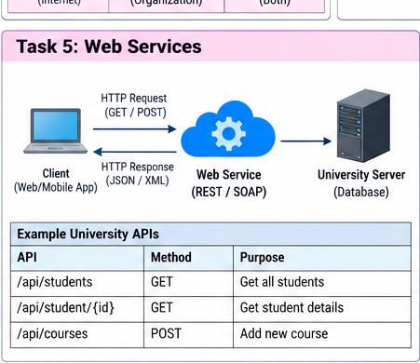
5.1. Three university web-service examples

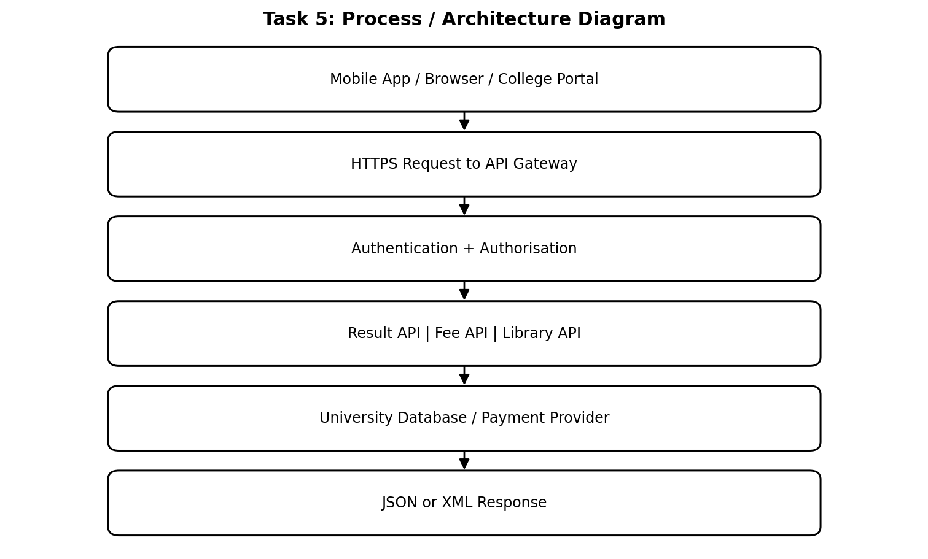

5.2. Explanation of the diagram
API 1 – Result lookup. Endpoint: GET /api/v1/students/{studentId}/results. Method: GET. Example request: GET /api/v1/students/10025/results with an authorised bearer token. Example JSON response: {"studentId":"10025","semester":4,"status":"Published","cgpa":8.2}. Use REST because the operation retrieves data and is suitable for mobile clients. The API must verify that the caller is the student or an authorised staff member.
API 2 – Fee payment. Endpoint: POST /api/v1/fees/payments. Method: POST. Example request: {"studentId":"10025","amount":12500,"paymentMode":"UPI"}. Example response: {"paymentId":"PAY7841","status":"Pending","currency":"INR"}. Use REST with a payment provider integration, idempotency key and server-side verification. Never trust a client-provided success message.
API 3 – Library search. Endpoint: GET /api/v1/library/books?query=database. Method: GET. Example response: {"items":[{"title":"Database Systems","availability":"Available"}]}. REST is suitable because it is a simple search operation with a compact JSON response.
Process interpretation: Each stage has a defined responsibility. Requests enter through a controlled network interface, are checked and processed by the relevant service, and reach stored information only through authorised application logic. The response then returns to the original user or calling application.

5.3. SOAP and REST comparison
Feature | SOAP | REST
Nature | Protocol with defined message rules | Architectural style
Common format | XML envelope | Often JSON; can also use XML
Transport | Commonly HTTP; other transports possible | Typically HTTP/HTTPS
Operations | Defined through service contract | Uses HTTP methods and resource URLs
Best fit | Formal enterprise integrations | Mobile apps, portals and lightweight APIs
University example | Legacy finance integration if contract requires it | Result lookup and library search

5.4. Analysis and application to the university
Request and response handling. The API gateway receives the request, checks the token and applies rate limits. The relevant service validates the request, performs the business operation and accesses the required database or payment provider. It returns a response with an HTTP status code and a JSON or XML body. A 200 response indicates a successful request; 400 indicates invalid input; 401/403 indicates authentication or permission failure; 404 indicates a missing resource.
Security and recommendation. Use REST for result lookup, fee initiation and library search because the university needs mobile and partner-college integration. Fee payment must additionally use transaction records, idempotency, payment-provider callbacks and reconciliation. If an existing finance partner mandates SOAP and WSDL, retain a SOAP adapter at the integration boundary rather than forcing every new client to use SOAP.
Therefore, REST is the preferred approach for new mobile and college-facing services, while SOAP can be retained where a legacy partner requires a formal SOAP contract.

6 – CLOUD SERVICE MODELS: IAAS, PAAS AND SAAS

6. Introduction and core concepts
IaaS – Infrastructure as a Service. IaaS provides virtual machines, storage and networking. The provider manages physical data-centre hardware and virtualisation, while the university manages operating systems, middleware, applications, data and much of the security configuration. It offers high control and supports legacy software, but requires system administration and patching.
PaaS – Platform as a Service. PaaS provides a managed application runtime, deployment environment and supporting platform. The provider manages infrastructure, operating system and runtime components. The university focuses on application code, configuration and data. It reduces maintenance and speeds development, but platform restrictions and provider-specific services can create lock-in.
SaaS – Software as a Service. SaaS delivers a complete application over the internet. The provider manages the application and underlying platform; the university manages users, configuration, access policies and its data responsibilities. SaaS is suitable for standard functions such as email, but offers less control over custom features.
Five-application mapping. A practical mix is: SIS on IaaS initially to preserve legacy compatibility; LMS on SaaS if its academic and integration features meet requirements; Library system on PaaS when custom integration is needed; Exam portal on PaaS or container-based IaaS depending on examination controls; and Email on SaaS. The final choice depends on data protection, integration, cost and feature fit.
The shared-responsibility model is central to service-model selection. Moving a workload to SaaS reduces infrastructure work, but the university remains responsible for selecting authorised users, configuring retention and protecting its information.
A workload should not be placed in SaaS merely because SaaS requires less maintenance. The university must verify that the service supports required academic workflows, data export, identity integration, audit records and contractual obligations.
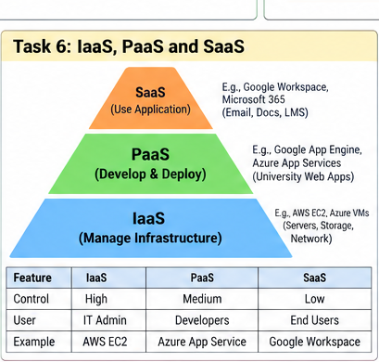

6.1. Responsibility layers in service models

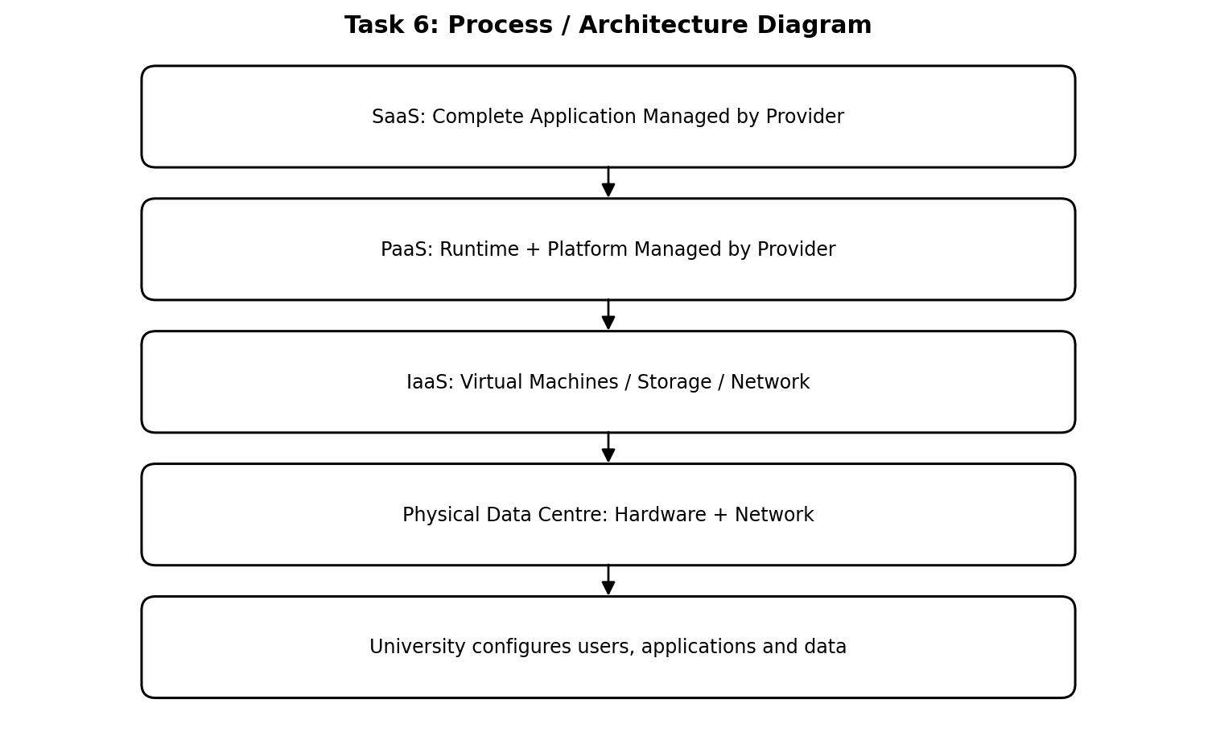

6.2. Explanation of the diagram
Responsibility interpretation. The service model changes who operates each technical layer; it does not remove the university's responsibility for appropriate data governance, user access, lawful processing and configuration. For example, even when email is SaaS, the university must disable accounts promptly when staff leave and apply multi-factor authentication.
Provider examples. IaaS examples include Amazon EC2, Microsoft Azure Virtual Machines and Google Compute Engine. PaaS examples include Azure App Service, Google App Engine and AWS Elastic Beanstalk. SaaS examples include Microsoft 365 and Google Workspace. These are examples of service categories; provider selection requires a separate cost, security and contract review.
Process interpretation: Each stage has a defined responsibility. Requests enter through a controlled network interface, are checked and processed by the relevant service, and reach stored information only through authorised application logic. The response then returns to the original user or calling application.

6.3. Application mapping and service-model comparison

University application | Suggested model | Reason
Student Information System (SIS) | IaaS initially | Legacy application may need OS-level control; migrate in stages
Learning Management System (LMS) | SaaS | Standard learning, course and assignment features may be available as a managed product
Library System | PaaS | Custom catalogue integration can be deployed without managing servers
Exam Portal | PaaS / container IaaS | Elastic application tier; stronger control may be needed for secure exams
Email | SaaS | Mature hosted email reduces local maintenance

6.4. Analysis and application to the university
Model comparison. IaaS provides the highest infrastructure control but also the greatest maintenance effort. PaaS reduces operating-system and runtime administration and is useful for new APIs. SaaS offers the least infrastructure maintenance and fastest adoption, but configuration and customisation may be limited. Costs shift from capital expenditure to recurring operating expenditure; usage, licences, data transfer and support must all be included.
Recommendation. Use a mixed model rather than forcing all five applications into one category. Retain the SIS on IaaS during the first migration phase, select SaaS for email and a suitable LMS, and build university-specific APIs on PaaS. Review vendor lock-in, export formats, uptime commitments, data location and exit costs before signing contracts.
Therefore, a mixed IaaS, PaaS and SaaS strategy is more appropriate than using one model for every university application.

TASK 7 – ANYTHING AS A SERVICE (XAAS)

7. Introduction and core concepts
Meaning of XaaS. XaaS means Anything-as-a-Service. It is a broad term for technology capabilities delivered over a network as managed services rather than owned and operated entirely by the customer. The university can consume selected functions on demand, reducing the need to build every technical capability itself.
Important variants. 1. DBaaS (Database as a Service): managed database provisioning, patching, backups and scaling. 2. DRaaS (Disaster Recovery as a Service): recovery infrastructure and replication for continuity after a failure. 3. FaaS (Function as a Service): runs small event-triggered functions without managing servers. 4. BaaS/MBaaS (Backend/Mobile Backend as a Service): provides mobile identity, notifications and backend features. 5. Security-as-a-Service: managed security monitoring or threat protection. 6. DaaS may mean Desktop as a Service or Data as a Service; the exact meaning must be defined in the contract.
University benefits. Managed services can reduce routine maintenance and allow a small IT team to focus on academic systems. They can also provide specialised capabilities such as database backups, recovery replication and mobile notifications. The university must still verify security, availability, data ownership and service-level commitments.
XaaS offerings should be selected because they solve a specific operational problem, not because the provider offers many service labels. Each service adds a dependency, contract, identity integration and possible data-transfer cost.
The university should document service owners, escalation contacts, data locations, recovery commitments and exit procedures for every XaaS provider.

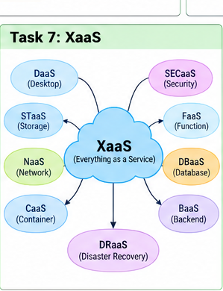
7.1. XaaS use in the university
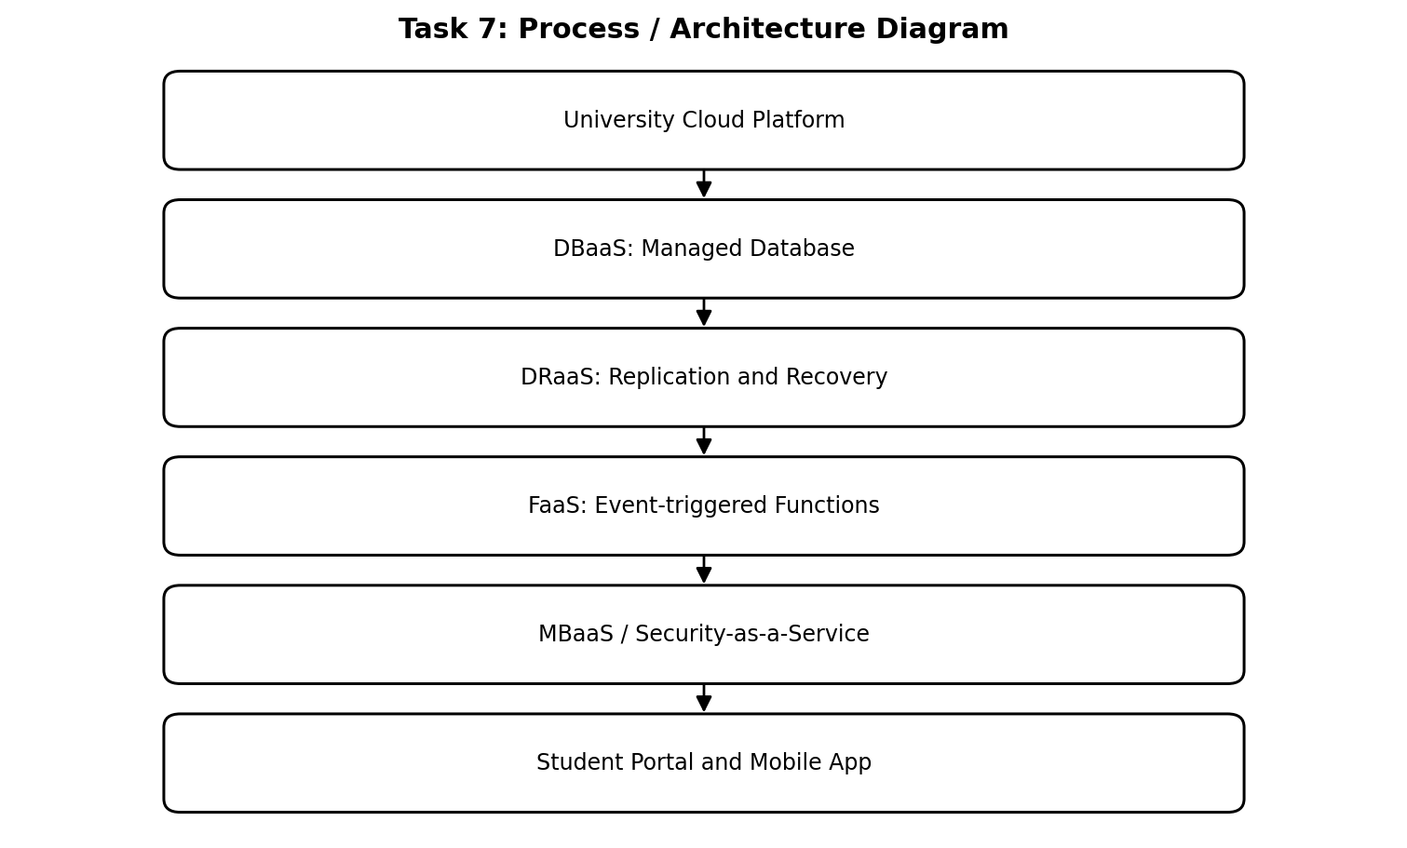

7.2. Explanation of the diagram
Recommended choice 1 – DBaaS. DBaaS is recommended for suitable new or migrated application databases. It can automate backups, patching, monitoring and supported scaling. The university should configure private connectivity, encryption, role-based access, retention and tested restore procedures. A managed database is not automatically protected from accidental deletion or poor access control.
Recommended choice 2 – DRaaS. DRaaS is recommended because the current environment has no disaster-recovery site. Replication and documented recovery procedures can reduce the impact of a data-centre outage. Define recovery time objective (RTO) and recovery point objective (RPO), test failover regularly and ensure that backups are protected from ransomware and administrative mistakes.
Other useful variants. FaaS can process events such as sending a fee receipt or notifying a student when results are published. MBaaS can support mobile authentication and push notifications. Security-as-a-Service can provide centralised threat detection, but alerts must be reviewed and acted upon by the university's security team.
Process interpretation: Each stage has a defined responsibility. Requests enter through a controlled network interface, are checked and processed by the relevant service, and reach stored information only through authorised application logic. The response then returns to the original user or calling application.

7.3. XaaS comparison and provider risks
Variant | What it provides | Example university use | Key control
DBaaS | Managed database | Student or library database | Encryption, access and restore tests
DRaaS | Recovery environment and replication | Recover portal after regional outage | RTO/RPO and failover tests
FaaS | Event-triggered functions | Send result notification | Execution limits and secure secrets
MBaaS | Mobile backend capabilities | Mobile login and push notifications | Identity and data minimisation
Security-as-a-Service | Managed security capabilities | Threat monitoring | Alert ownership and incident response
DaaS | Desktop or data service, depending on definition | Virtual lab desktop or governed data access | Clarify scope and data rights

7.4. Analysis and application to the university
Risks of depending on many providers. Multiple providers can create fragmented identity, inconsistent security policies, integration complexity and difficult incident ownership. Data transfer and egress charges may increase costs. Provider outages or contract changes can affect critical services. Different backup and logging systems can make investigations difficult.
Risk reduction. Maintain a provider inventory, standardise identity through central single sign-on, use documented APIs, encrypt data, retain independent backups and test data export. Contracts should specify availability, support response, data location, breach notification, recovery and termination assistance. Select DBaaS and DRaaS first because they directly address database operations and the absence of recovery capability.
Therefore, DBaaS and DRaaS are the two strongest initial XaaS choices because they address database operations and the university's current lack of disaster recovery.

8 – CLOUD SOLUTION ARCHITECTURE

8. Introduction and core concepts
Design objective. The proposed architecture migrates the university's SIS, LMS, library, examination portal and email from 12 under-used physical servers to a secure, scalable hybrid-cloud environment. It must support approximately 25,000 students and 2,000 staff across four campuses, improve peak capacity and introduce disaster recovery.
Deployment and service choices. Use a hybrid deployment during migration. Public-cloud services host the internet-facing load balancer, web tier, API gateway and scalable application services. Sensitive databases use private subnets and strict access controls. Use IaaS for legacy VMs, PaaS for new APIs and application services, SaaS for suitable email/LMS capabilities, and DBaaS where governance and compatibility permit.
Architecture components. Users connect through HTTPS. A web application firewall and load balancer distribute traffic across multiple application instances. The API gateway authenticates and routes mobile and partner-college requests. Application services connect to private databases and object storage. Monitoring, logging, backup and a separate disaster-recovery region support operations.
The architecture separates the internet-facing entry points from private data resources. This reduces direct exposure of databases and makes it possible to scale the application tier independently from storage and database capacity.
The architecture is logical and must be converted into a tested deployment plan. Sizing requires concurrent-user estimates, request rates, storage growth, database I/O and recovery objectives.

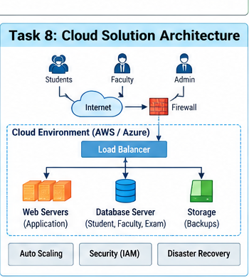
8.1. Proposed labelled cloud architecture

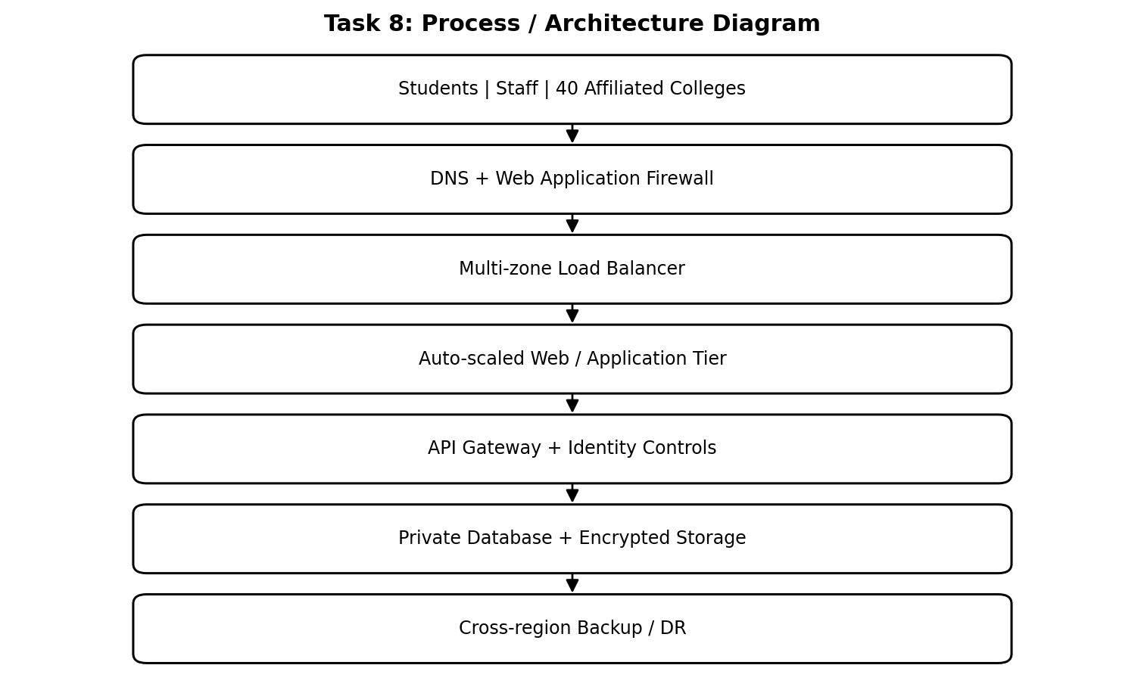

8.2. Explanation of the diagram
Traffic and scaling flow. DNS directs users to the cloud entry point. The web firewall filters common malicious traffic. The load balancer distributes requests across healthy instances. Auto-scaling adds application instances when CPU, request count or queue length rises and removes excess instances when demand falls. The API gateway applies authentication, authorisation and rate limits before requests reach internal services.
Security and availability. Use multi-factor authentication for administrators, role-based access for users, encryption in transit and at rest, private database subnets, secrets management and central audit logs. Deploy critical components across multiple availability zones. Back up databases and files to a separate recovery region. Test restoration and failover rather than relying only on a successful backup status.
Process interpretation: Each stage has a defined responsibility. Requests enter through a controlled network interface, are checked and processed by the relevant service, and reach stored information only through authorised application logic. The response then returns to the original user or calling application.

8.3. Component justification and design controls
Component | Model / placement | Purpose and justification
Load balancer + firewall | Managed cloud service / public edge | Distributes traffic and filters unsafe requests
Web and application tier | PaaS or container-based IaaS | Scales during admissions and exams
API gateway | Managed PaaS service | Controls mobile and college API access
Legacy SIS | IaaS VM in private network | Supports existing application during migration
Database | DBaaS or managed IaaS database | Persistent records, backup and controlled access
File storage | Cloud object storage | Documents, learning content and exam files
DR region | DRaaS / replicated cloud resources | Recovery after regional failure
Email | SaaS | Reduces local server administration

8.4. Analysis and application to the university
Design assumptions. Initial sizing must be based on measured concurrent users, request rates, database IOPS, storage growth and network throughput. The architecture diagram is logical, not a final bill of materials. Load tests must establish safe autoscaling thresholds and database connection limits. Availability depends on the whole service chain, including DNS, identity, network, database and external payment services.
Conclusion. The hybrid architecture supports gradual migration and avoids a risky one-time replacement. It separates public-facing services from private data, uses APIs for integration and scales the application tier independently. Multi-zone deployment and a tested DR region improve resilience while managed services reduce routine administration.
Therefore, the proposed hybrid cloud architecture combines controlled access, independent scaling, managed services and recovery capabilities to support the university's migration.

9 – HANDS-ON IMPLEMENTATION AND DOCUMENTATION

9. Introduction and core concepts
Proof-of-concept objective. This task demonstrates one university function as a small REST API, packaged in a Docker container and tested locally. The example is a student result lookup endpoint. The assignment brief permits a local virtualisation tool or a free-tier cloud account. The steps below are reproducible; actual execution screenshots and output must be captured from the student's own environment and must not be represented by invented evidence.
Tools required. Install Python 3, Docker Desktop and a code editor. Create a project folder containing app.py, requirements.txt and Dockerfile. The Flask framework provides a simple HTTP endpoint. Docker packages the application and its dependencies into a container image so that it can run consistently on a compatible host.
Sample application. The API returns a demonstration record for a student identifier. It is sample data only and must not contain real student personal information. In a real system, the endpoint must authenticate the caller, authorise access to the requested record and read data from a protected database.
The purpose of the proof-of-concept is to demonstrate the deployment chain: source code, dependency definition, container image, running container, HTTP request and returned JSON. A screenshot should show the command or tool, the endpoint and the actual result.
Use only demonstration records in the sample. A production implementation requires authentication, authorisation, secure configuration, database connectivity, logging and privacy review.

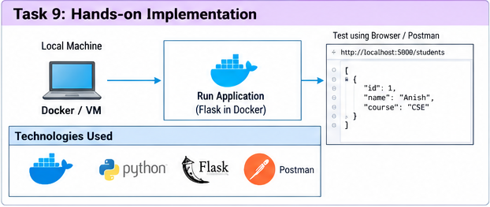
9.1. Implementation flow and sample code

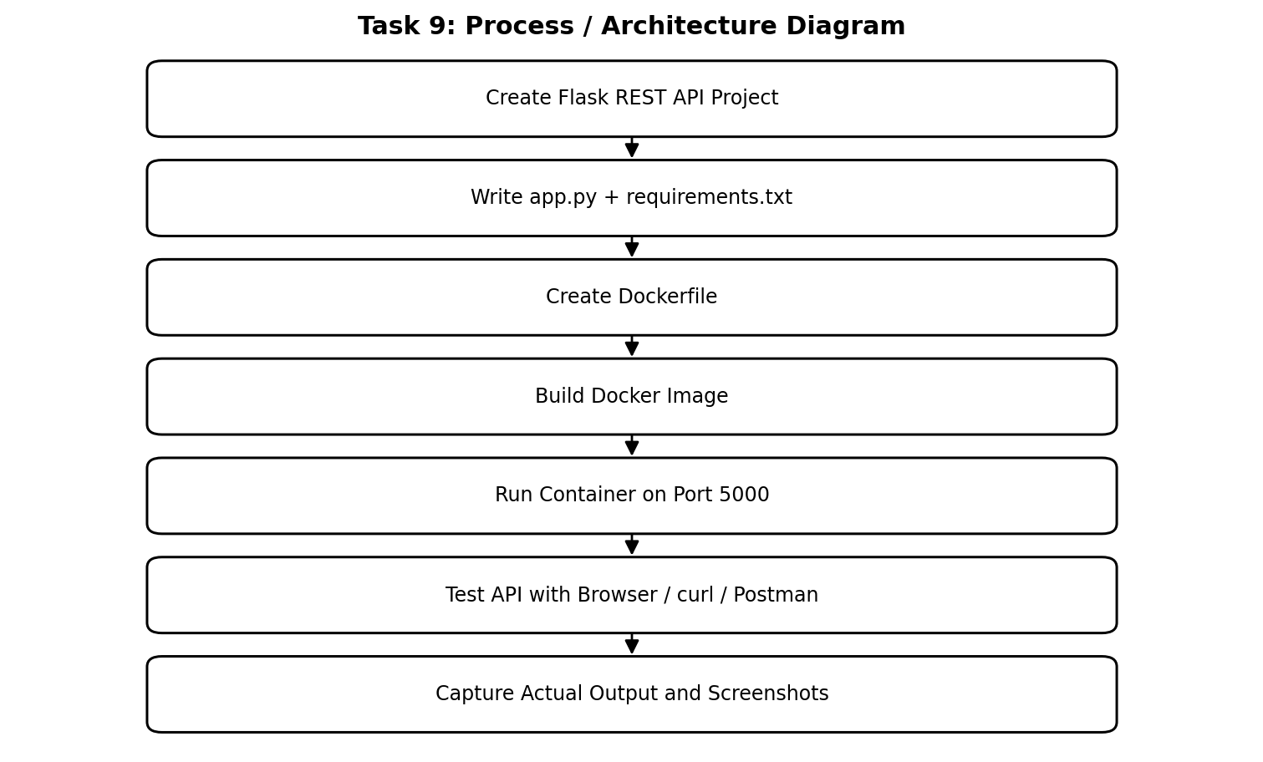
9.2. Explanation of the diagram
app.py. from flask import Flask, jsonify
app = Flask(__name__)
@app.get('/api/v1/results/<student_id>')
def get_result(student_id):
demo = {'studentId': student_id, 'semester': 4,
'status': 'Published', 'cgpa': 8.2}
return jsonify(demo), 200
if __name__ == '__main__':
app.run(host='0.0.0.0', port=5000)
requirements.txt. Flask==3.1.0
Dockerfile. FROM python:3.12-slim
WORKDIR /app
COPY requirements.txt .
RUN pip install --no-cache-dir -r requirements.txt
COPY app.py .
EXPOSE 5000
CMD ["python", "app.py"]
Build and run commands. docker build -t university-results-api .
docker run --name results-api -p 5000:5000 university-results-api
Test in browser: http://localhost:5000/api/v1/results/10025
Or use curl: curl http://localhost:5000/api/v1/results/10025
Process interpretation: Each stage has a defined responsibility. Requests enter through a controlled network interface, are checked and processed by the relevant service, and reach stored information only through authorised application logic. The response then returns to the original user or calling application.

9.3. Testing, evidence and limitations
Test | Action | Expected result | Evidence to capture
Build | Run docker build command | Image builds without error | Terminal screenshot showing build completion
Container | Run docker ps | Container is running and port 5000 is mapped | Docker Desktop or terminal screenshot
Success case | GET /api/v1/results/10025 | HTTP 200 with JSON result | Browser/Postman/curl response
Failure case | GET /unknown/path | HTTP 404 Not Found | Actual failure response screenshot
Reproducibility | Stop and restart container | API responds again after restart | Commands and output

9.4. Analysis and application to the university
PaaS extension. For a cloud deployment, create a managed web-app service in a selected provider, configure the application runtime or container image, set environment variables and deploy from a repository or registry. Configure HTTPS and restrict access to the database. Record the selected provider, region, service tier and deployment settings in the report.
Implementation evidence note. The assignment rubric asks for a running VM/container, PaaS or SaaS deployment, actual tests, API output and screenshots. This document supplies code and reproducible commands but cannot truthfully claim that the commands were executed on the student's computer. Insert genuine screenshots in the evidence table after running the steps. Include any errors faced and how they were corrected.
Security and improvement. The sample endpoint is intentionally simple and uses demonstration data. A production result service must use authentication, role-based permissions, input validation, HTTPS, rate limiting, structured logs, database parameterisation and privacy controls. Secrets must be stored in a secure configuration service, not committed to source code.
Therefore, the proof-of-concept demonstrates the basic deployment and API-testing method; genuine execution evidence must be added before submission.

10 – EVALUATION AND FINAL RECOMMENDATION

10. Introduction and core concepts
Evaluation criteria. The final choice must balance three-year cost, scalability, availability, security and management effort. The university's current model has 12 physical servers, low average utilisation, high peak demand, slow procurement and no disaster recovery. A cloud migration changes much of the initial capital expenditure into recurring operating expenditure.
Three alternatives. Option A: retain on-premises servers and purchase additional peak capacity. This gives direct control but requires capital investment, procurement lead time, power, cooling, maintenance and a separate DR site. Option B: migrate to IaaS. This reduces hardware ownership and supports legacy workloads, but the university still manages operating systems, middleware and applications. Option C: use a PaaS/SaaS-led mix. This reduces infrastructure administration and speeds scaling, but may increase subscription and integration costs and create vendor dependence.
Cost assumptions. The following is an illustrative planning estimate in Indian rupees, not a provider quotation. Assume on-premises refresh, maintenance and DR cost ₹45 lakh per year; IaaS migration and operation cost ₹36 lakh per year; and a PaaS/SaaS-led mix costs ₹32 lakh per year. One-time migration costs are assumed to be ₹8 lakh for IaaS and ₹10 lakh for PaaS/SaaS. Actual cost depends on sizing, licences, storage, data transfer, support, taxes and negotiated discounts.
A fair comparison must use the same workload scope and service quality assumptions for all three alternatives. Include hardware refresh, maintenance, licences, staff effort, connectivity, backup, disaster recovery, cloud support, data transfer and migration.
The lowest estimated total is not automatically the best decision if it cannot meet security, availability or application-compatibility requirements. Cost must be evaluated together with risk and operational capability.

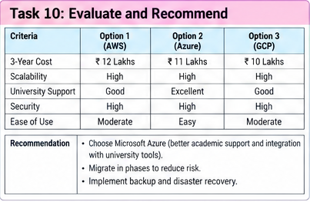
10.1. Three-year cost comparison and migration flow

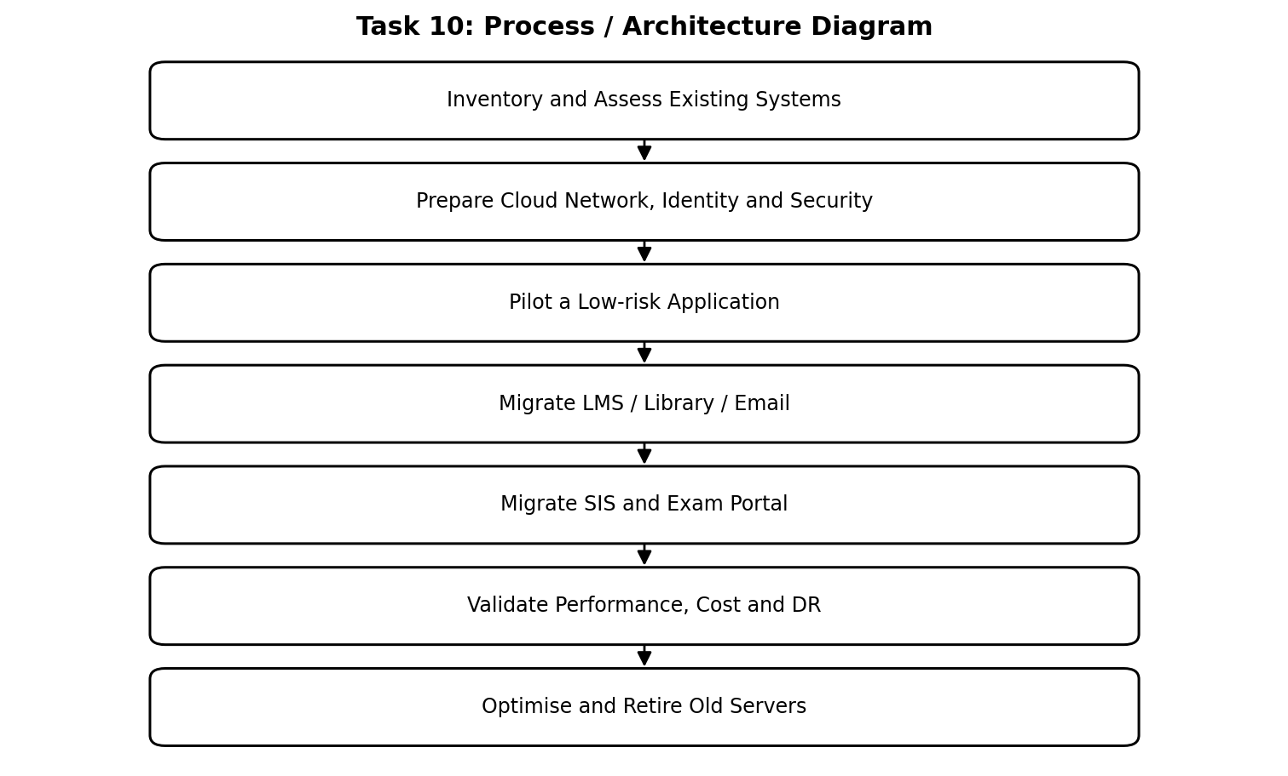
10.2. Explanation of the diagram
Illustrative three-year calculation. On-premises: ₹45 lakh × 3 = ₹135 lakh. IaaS: ₹36 lakh × 3 + ₹8 lakh migration = ₹116 lakh. PaaS/SaaS-led: ₹32 lakh × 3 + ₹10 lakh migration = ₹106 lakh. Under these assumptions, PaaS/SaaS-led has the lowest estimated three-year total. The comparison excludes exceptional growth, major application redevelopment and contract-specific charges; it must be recalculated using provider pricing and measured workloads.
Migration roadmap. Phase 1: inventory applications, data, dependencies and security requirements. Phase 2: establish identity, network connectivity, logging, backup and governance. Phase 3: pilot a low-risk web service. Phase 4: migrate LMS, library and email where SaaS/PaaS fit. Phase 5: migrate SIS and examination workloads after performance and security testing. Phase 6: validate DR, optimise cost and retire unused servers.
Process interpretation: Each stage has a defined responsibility. Requests enter through a controlled network interface, are checked and processed by the relevant service, and reach stored information only through authorised application logic. The response then returns to the original user or calling application.

10.3. Comparison, risks and final recommendation

Factor | On-premises | IaaS-based | PaaS/SaaS-led
Cost pattern | High CapEx + local operations | Recurring infrastructure charges + admin | Subscriptions / managed-service charges
Scalability | Requires procurement | Flexible VM scaling | Managed scaling for supported services
Availability | University must build redundancy | Cloud zones available; design required | Provider manages much of platform availability
Security | Direct control; local skills needed | Shared responsibility | Configuration and data governance remain essential
Effort | High hardware and patching effort | OS and application administration | Lower infrastructure maintenance

10.4. Analysis and application to the university
Main risks and mitigation. Vendor lock-in: use documented APIs, standard data formats and tested export procedures. Data privacy: encrypt data, apply least privilege and review data location and contracts. Downtime: deploy across zones, monitor dependencies and test DR. Skills gap: train administrators and retain clear operating procedures. Cost growth: set budgets, alerts, tagging and periodic rightsizing.
Final recommendation. Choose a hybrid, PaaS/SaaS-led cloud solution with IaaS retained temporarily for legacy SIS components. This provides a practical transition path, reduces hardware ownership and supports elastic web services. The illustrative cost model favours PaaS/SaaS-led adoption, but final procurement must use measured workload data and binding provider quotations.
Therefore, a phased hybrid, PaaS/SaaS-led solution is recommended, subject to provider quotations, workload measurement and security review.

11 – DAY-4 DESIGN CHALLENGE: RE-EVALUATE AND ADAPT

11. Introduction and core concepts
Changed requirements. The university now plans a mobile app and will expose student-record and fee-payment services to 40 affiliated colleges. Expected load is 10 times the current peak, availability must be 99.9%, and the operating budget is limited. The original architecture must therefore be reviewed for capacity, security, multi-tenancy, availability and cost.
Impact on assumptions. The number of external clients increases, traffic becomes less predictable and sensitive student/fee services are exposed beyond the university's own campuses. API design becomes critical because the mobile app and colleges need stable, controlled interfaces. Multi-tenancy means each college must access only its own permitted records, while university administrators may have broader authorised roles. Authentication alone is not sufficient; every request must enforce tenant-level authorisation.
Decision. Modify the original design rather than retain it unchanged or replace it completely. Keep the hybrid-cloud foundation, but strengthen the API gateway, use horizontally scalable containers or PaaS services, introduce tenant-aware authorisation, deploy critical services across multiple availability zones and maintain a separate disaster-recovery region.
The new requirement changes both scale and trust boundaries. Forty colleges are external tenants, so the system must prevent one college from accessing another college's records even if a user changes a URL or request parameter.
Availability is an end-to-end property. A resilient application tier cannot meet the target if the identity provider, database, DNS or payment integration remains a single point of failure.

11.1. Revised architecture for 10× load and 99.9% availability

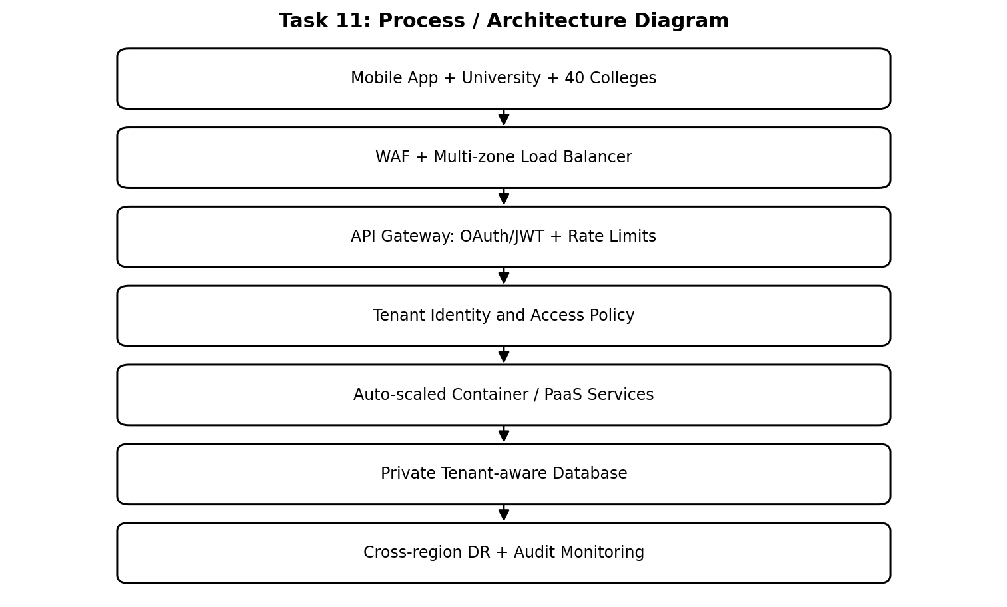
11.2. Explanation of the diagram
Capacity strategy. If the current peak request rate is represented by P, the revised expected peak is 10P. The application tier should be load-tested at or above 10P with a safety margin. Use horizontal scaling, caching for suitable read-only data, asynchronous queues for notifications and background work, and database connection pooling. Do not assume that adding ten times as many web servers will automatically make the database or payment provider ten times faster.
99.9% availability. A 99.9% annual availability target permits approximately 0.1% downtime: 8.76 hours in a 365-day year. Multi-zone deployment reduces the risk of a single-zone failure, but the end-to-end service also depends on identity, DNS, database, network and payment services. Define service-level objectives, monitor latency and error rates, and test recovery procedures.
Multi-tenant security. Use a trusted tenant identifier derived from the authenticated identity, not from an unverified request parameter. Enforce tenant scope in every API and database query. Separate college roles, apply rate limits per tenant, log administrative access and test for cross-tenant data leakage. Fee-payment operations require idempotency, signed provider callbacks and reconciliation.
Process interpretation: Each stage has a defined responsibility. Requests enter through a controlled network interface, are checked and processed by the relevant service, and reach stored information only through authorised application logic. The response then returns to the original user or calling application.

11.3. Evaluation, trade-offs and evidence-based defence
Area | Original design | Revised design
Traffic | Normal peak assumptions | Designed and tested for 10× current peak
Application tier | Auto-scaled web/application instances | Container/PaaS horizontal scaling + queues and caching
API access | General API layer | API gateway with per-tenant identity, quotas and policies
Availability | Multi-zone and backup proposed | Multi-zone critical services + tested cross-region DR
Security | Role-based access and encryption | Tenant-aware authorisation, isolation tests and audit
Cost | Baseline cloud operating cost | Autoscaling, budgets, quotas and workload optimisation

11.4. Analysis and application to the university
Cost and trade-offs. The revised design may cost more during peak traffic because compute, database and network usage increase. A limited budget can be protected through autoscaling, per-tenant quotas, caching, scheduled non-production shutdowns, reserved capacity for predictable baseline workloads and cost alerts. More managed services reduce operational effort but may increase vendor lock-in and service charges.
Validation plan. Run load tests at 1×, 5× and 10× peak, then test a higher safety margin. Measure response time, error rate, database CPU, connection count and queue depth. Perform zone-failure and restore exercises. Test that College A cannot read College B's student record. Verify fee callbacks and duplicate payment requests. Record actual test results; do not claim 99.9% availability solely because the architecture is designed for it.
Final defence. Modify the original hybrid design. Retain the cloud foundation and phased migration plan, but add a robust API gateway, tenant-aware security, horizontally scalable services, multi-zone deployment and cross-region recovery. This is a proportionate response to the new requirements: it improves scale and isolation without discarding the existing migration investment.
Therefore, the original design should be modified with tenant-aware security, stronger API management, horizontal scaling and tested multi-zone and cross-region recovery.

